# CS 255 System Design Document Template

This template lays out all the different sections that you need to complete for Project Two. Each section has guidance to prompt your thinking. You will need to continually reference the interview transcript as you work to make sure that you are addressing your client’s needs. There is no required length for the final document. Instead the goal is to complete each section based on what your client’s needs are. Remove this note when you are finished, and replace all bracketed text with the relevant information.

## UML Diagrams

### UML Use Case Diagram

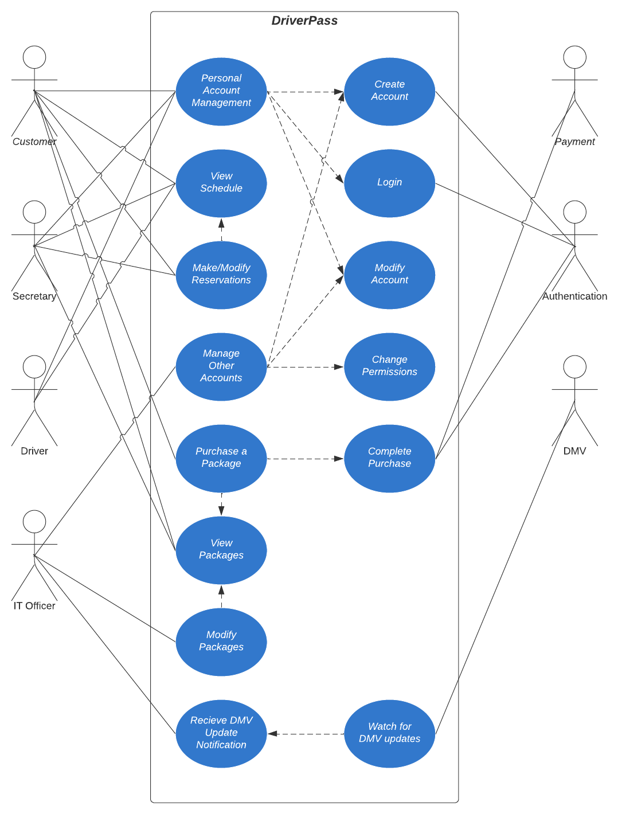

### UML Activity Diagrams

*

### UML Sequence Diagram

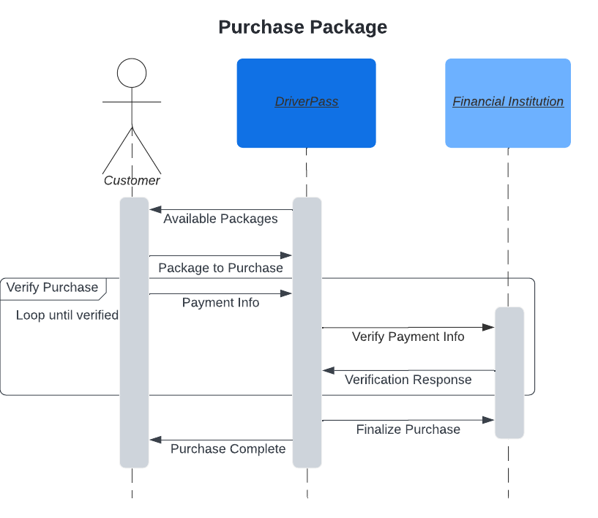

### UML Class Diagram

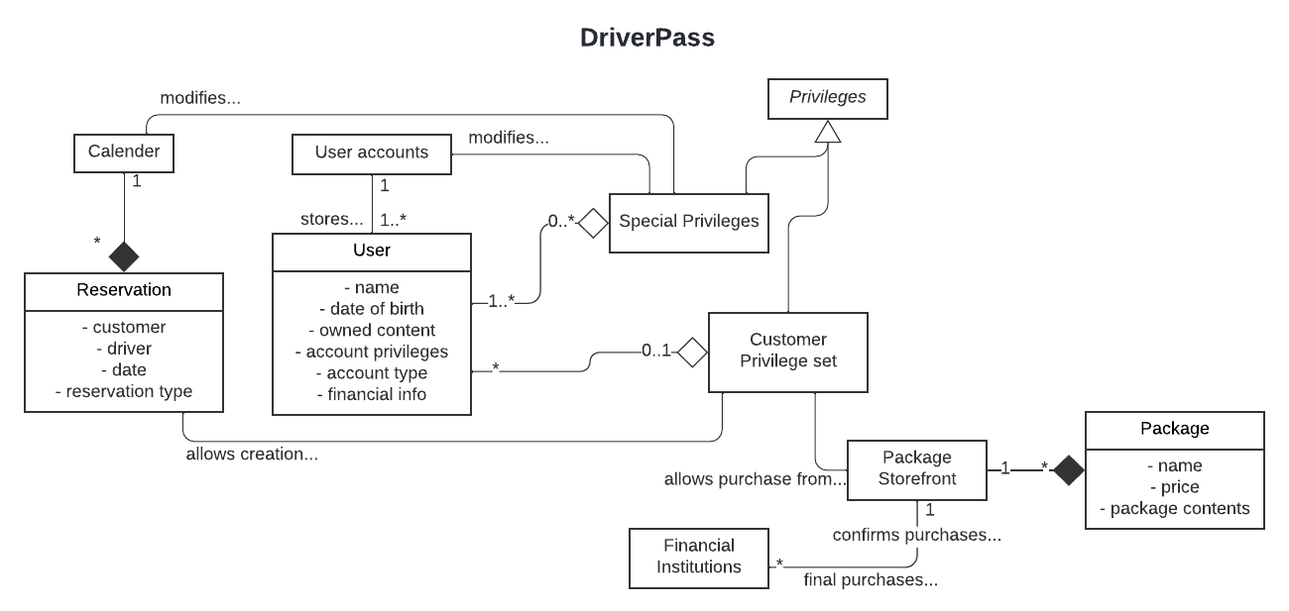

## Technical Requirements

The client has mentioned wanting the system to be both web-based and cloud-computed, so this system would need be setup in a cloud environment. Of course, this system would also need a website with its own GUI so that the system can be accessed. This system will be performing light computational work, so no special consideration should be needed for the system’s processing speed. The system would need special connections to verify purchases with banks and receive information from the DMV. While a database to store information is required, the data stored on within is system is extremely light and should require only a small database.